Tenda W6-S – How to login the configuration interface?

Scenario 1: When you got POE Switch to connect with the W6-S. Please login the configuration interface as follows.

- Hard connection: Connect the W6-S with router as the picture

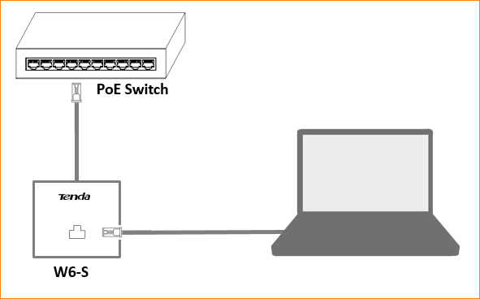

- Click on “Open Network & Internet setting” and click “Change adapter options”.

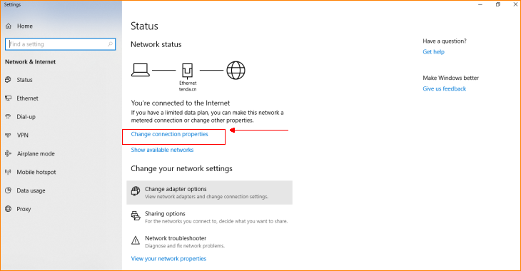

- Right click on the icon of Ethernet and click “Properties” to setup the static IP address of your PC as follows.

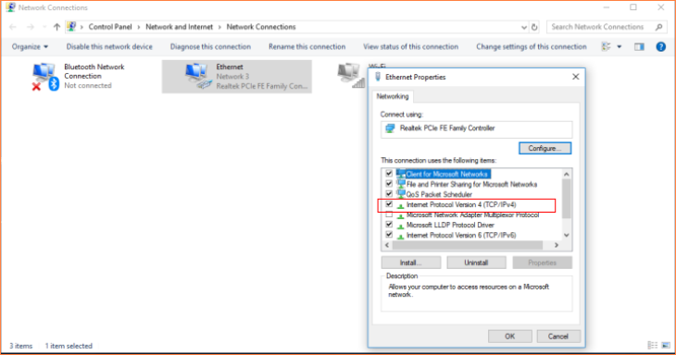

IP address:192.168.0. * (*:2~253)
Subnet mask:255.255.255.0
Default gateway:192.168.0.254

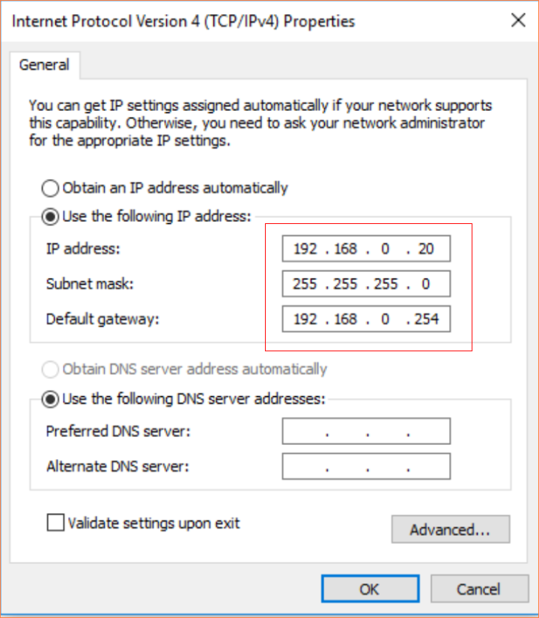

PS: Remember to click “OK” to save the configuration.

- Enter the address “192.168.0.254” into the address bar in any browser, and enter the default Name & Password (admin & admin) to login the configuration interface.

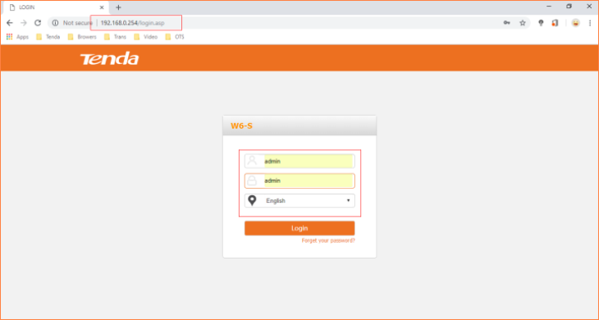

Scenario 2: If the W6-S obtain IP from Tenda router automatically, please login the settings interface as follows.

- Login router and find out the IP of W6-S based on MAC address at DHCP List of router.

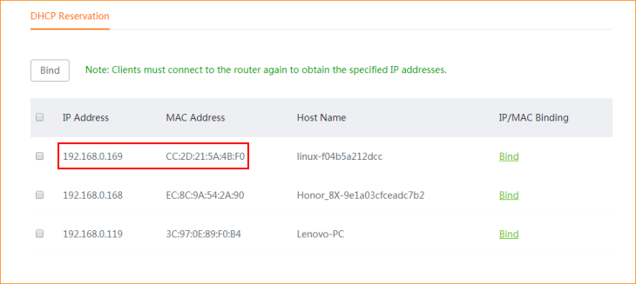

- Enter the IP address of AP into the address bar, and input the User Name & Password (default are: admin) to login the interface of W6-S.

